

Data Centre Gate Management System

Software Requirements Specification

SDC Team

November, 2021

Document Approval

The following Software Requirements Specification has been accepted and approved by the following:

|  |  |  |  |
| --- | --- | --- | --- |
| Signature | Name | Title | Date |
|  |  |  |  |

Table of Content

Contents

Introduction 4

Purpose 4

Scope 4

Overview 4

General Description 4

Product Functions 4

General Constraints 5

Assumptions and Dependencies 5

Specific Requirements 5

External Interface Requirements 5

User Interfaces 5

Hardware Interfaces 5

Software Interfaces 5

Communication Interfaces 5

Functional Requirements 5

Use Case Diagrams 9

Use Case – 01: Super Admin Login 9

Use Case – 02: System Users Registration 10

Use Case – 03: Reset Password 10

Use Case – 04: Remove Account 10

Use Case – 05: Login (All other users) 11

Use Case – 06: Fill Access Request Form 11

Logical Database Requirements 19

# Introduction

## Purpose

This document is written to give the developers details of what is going to be done in the project. This includes project structure, functional and non-functional requirement and how every feature of the system is intended to work like. Having this document, developers can keep track of the project and check if the requirements are met. And also have general understanding of the system.

## Scope

CBE’s DCGMS (Data Centre Gate Management System) is a platform where CBE employees or external visitors can request a physical access to the data centre of the bank. This system aims to automate the current system of access request, request confirmation and approval and notifications related to data centre. In this documentation, we have written all the necessary information for making the system starting from description of the system to the requirements that should be met when starting with the development, testing and deployment. The Functional requirements are described in terms of actors (System users) and also by use cases that are mentioned in this documentation.

## Overview

In the next sections, the document will cover the general description of the project which includes the functionality of the system and the constraints. This will be followed by the Specific Requirement section that describes the external interface requirements, functional requirements with the help of use cases and non-functional requirements. Design constraint, logical database requirements and other requirements will also be covered in this document.

# General Description

## Product Functions

By the end of this project, the system is expected to provide users an online data centre physical access request form and a system that enable the respective data centre authorities and admins to weather allow or deny access requests and monitoring the overall system.

DCGMS will allow visitors to submit physical access request form by logging into our system and wait for the response from data centre authorities. This is one of the main functionalities DCGMS has. Data centre managers can simply login and view lists of active physical access requests and their details. In addition to this, they system will allows them to weather confirm the request or deny it by stating appropriate denial reasons.

DCGMS will also allow the Infrastructure manager to finally approve the visit request. All approved requests will be sent to data centre admins and receptionists. Data centre admins and/ or receptionists will login to the system and view lists of approved requests visits with details and track and monitor visits. The system will provide them with the detail information about the visit and the remaining days for the visit.

DCGMS will send a notification for the access requestor whenever needed.

## General Constraints

During the implementation season, the following things are assumed to potentially limit developers’ option for designing the system:

1. Data centre manager, infrastructure manager and data centre admins and receptionists unwillingness to accept the system because of lack of seals.
2. Security

Only authorized users can access the system and necessary safety measures have to be taken by developers for the data not to be accessed by unauthorized person.

1. Responsive Site

## Assumptions and Dependencies

All users of the system should be in the bank’s local network since it will not work outside the bank’s network.

# Specific Requirements

In this part of the software requirement specification documentation we will clearly state how the System we are implementing function, its use cases, its user interface. The System shall have user interface that will be easy to use and access the right information at the right time.

## External Interface Requirements

### User Interfaces

In this section of the requirements we will clearly state what the user interface flow will look like and what its function will be.

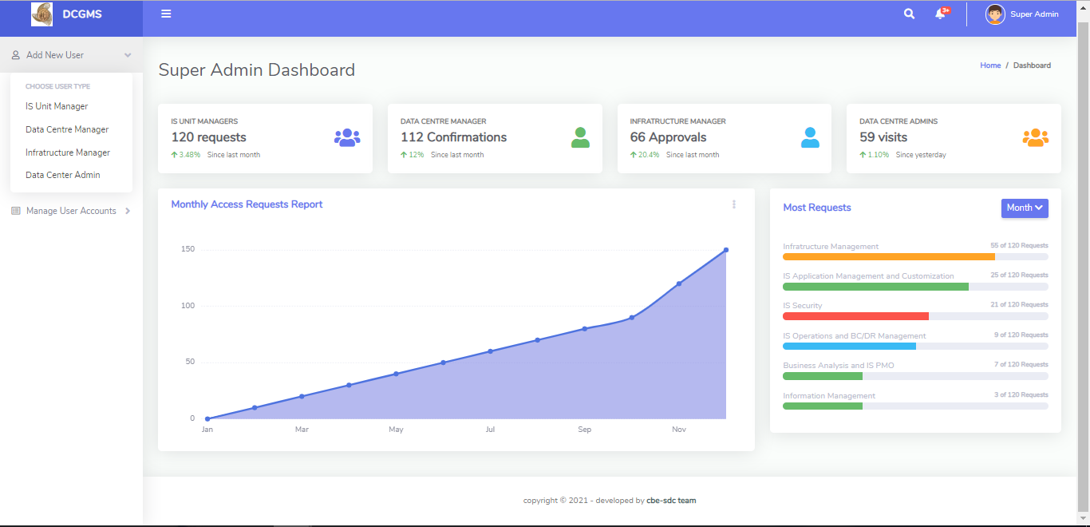Figure 1: Admin Dashboard

Figure 2: Admin Create IS Manager Account

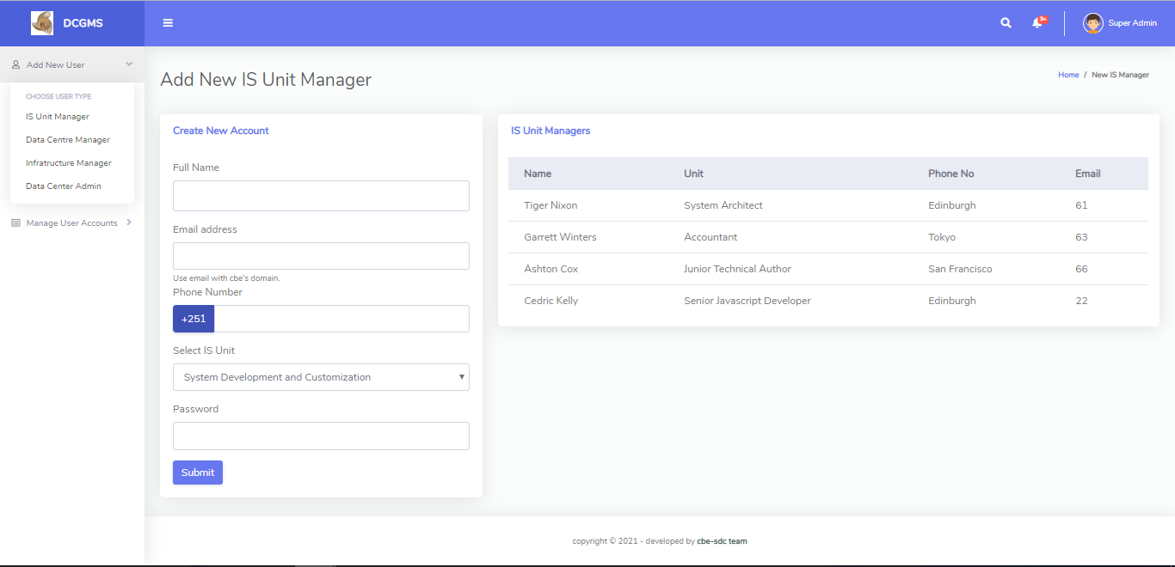

Figure 3: Admin create Infrastructure Manager

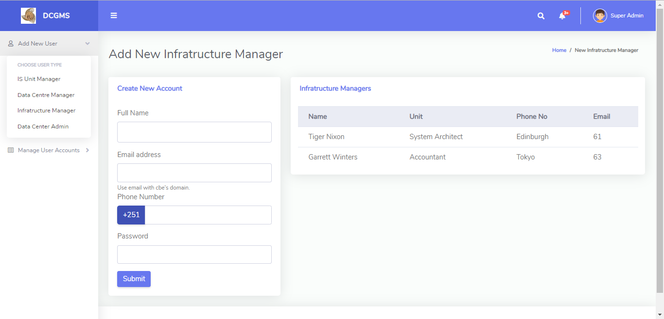

Figure 4: Admin Create Data Centre Manager

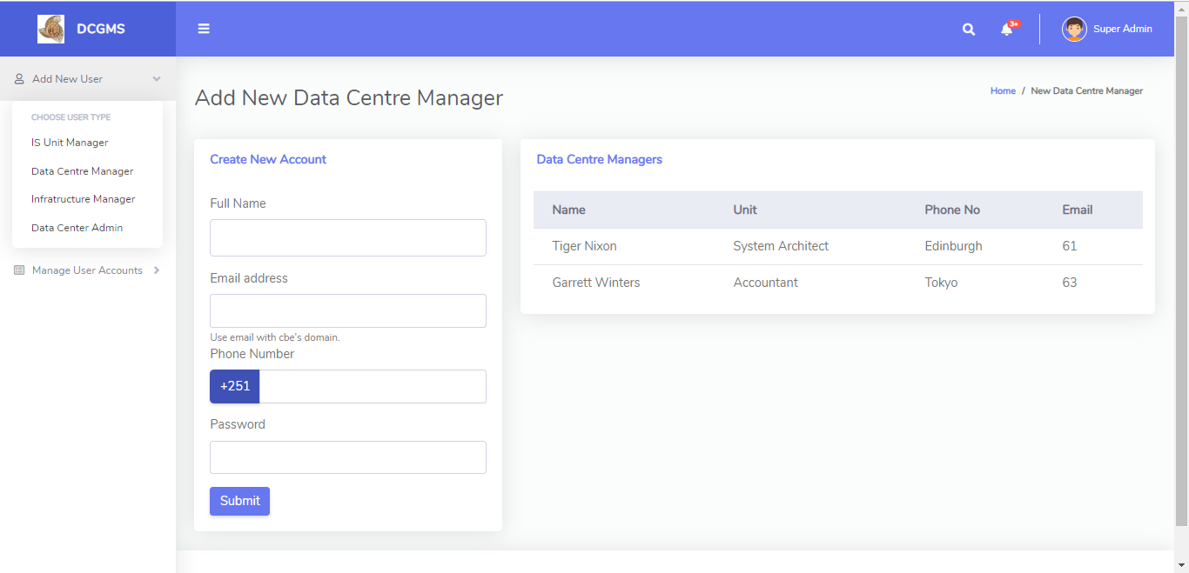

Figure 5: Admin Create Data Centre Admin

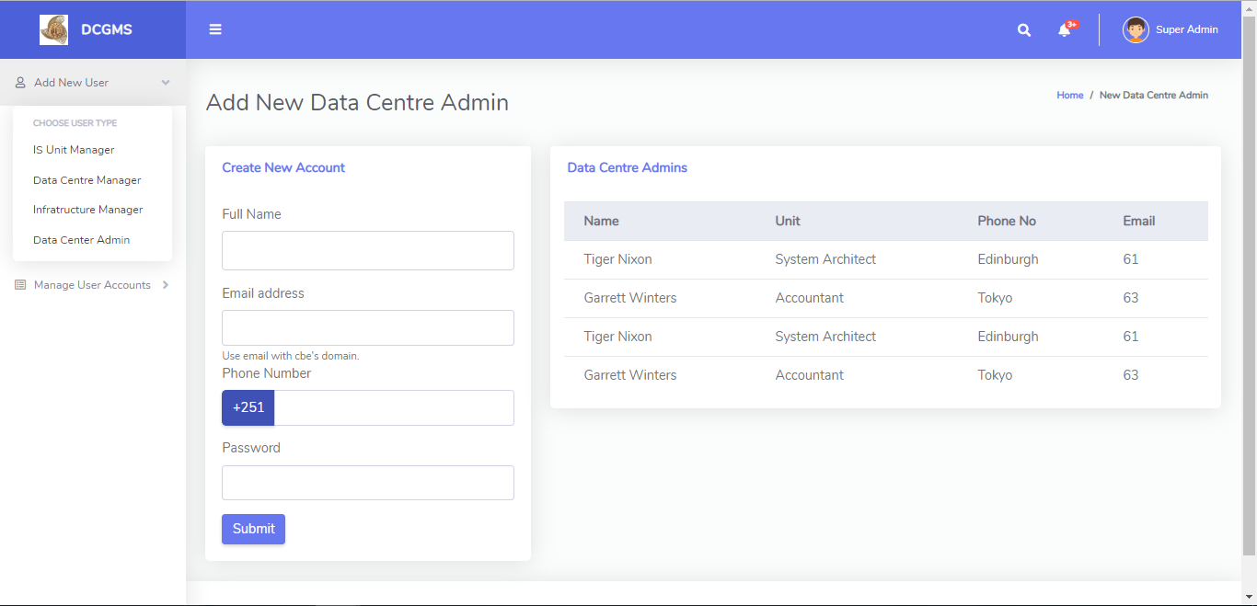

Figure 6: Admin Password Reset

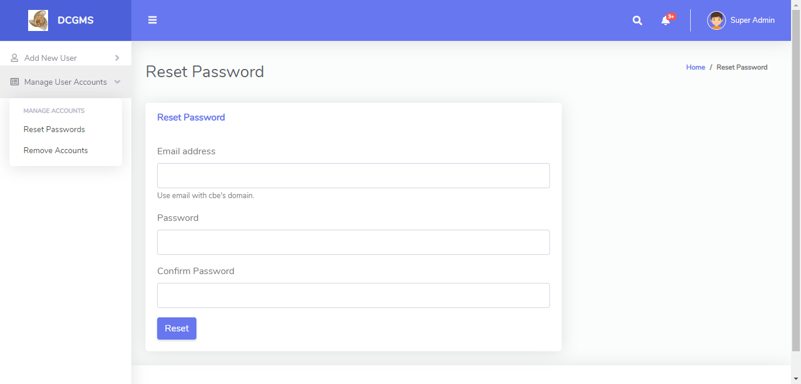

Figure 7: Admin Remove Accounts

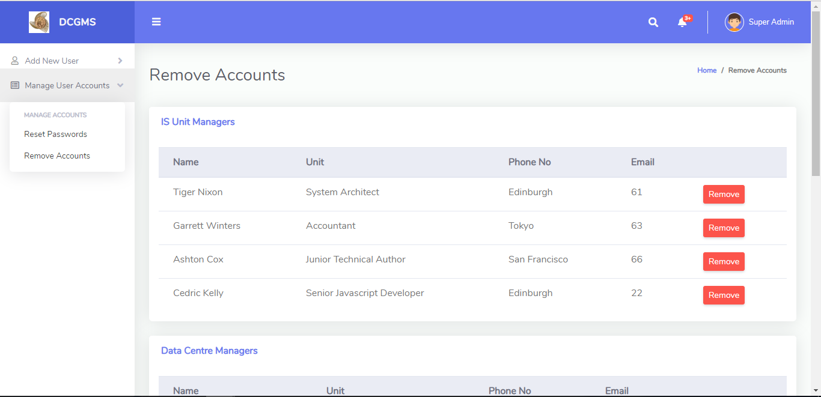

Figure 8: IS Unit Manager Fill Request Form

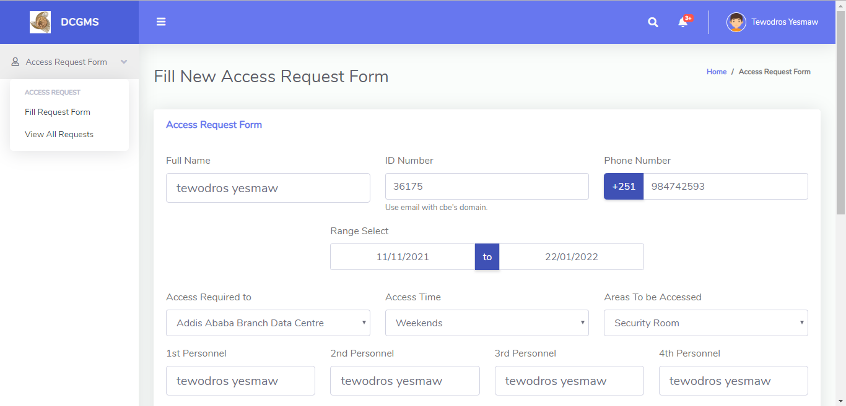

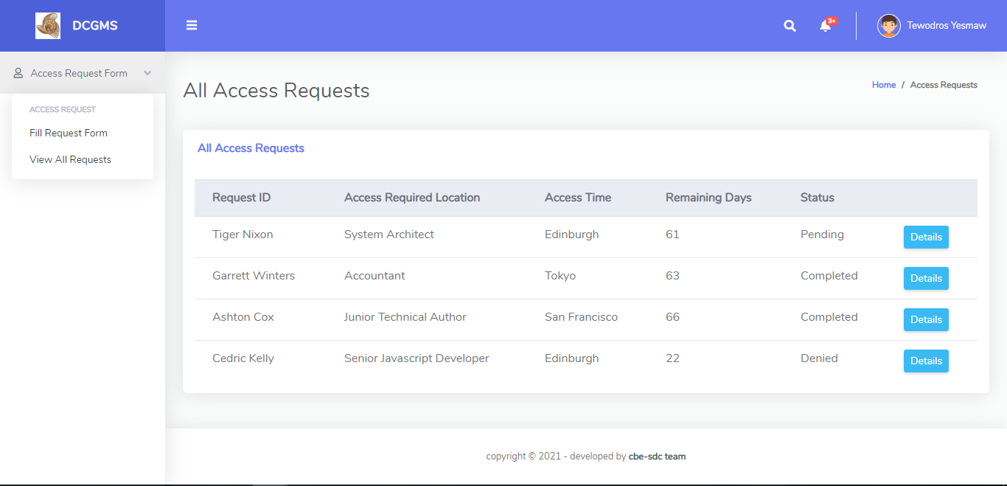Figure 9: Unit Manager All Requests

Figure 10: DC manager Requests

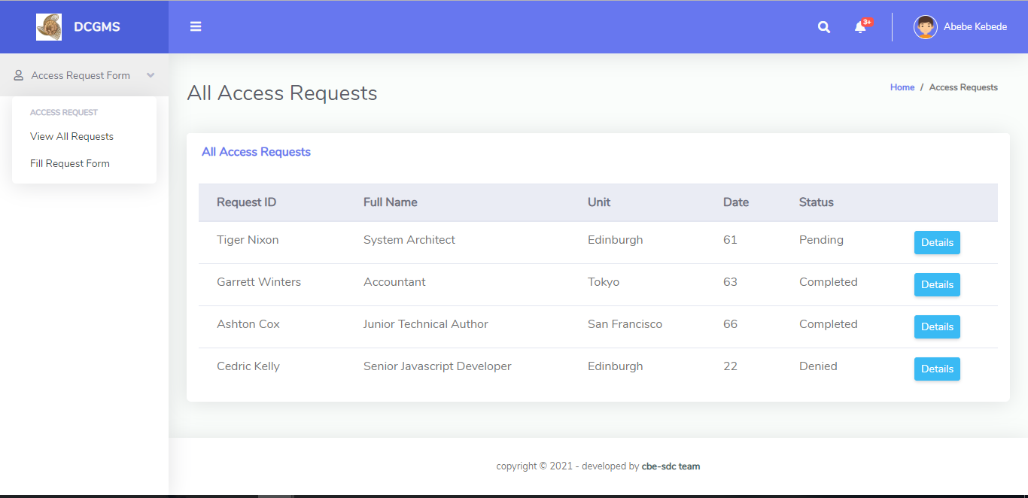

Figure 11: DC Manager Request Details

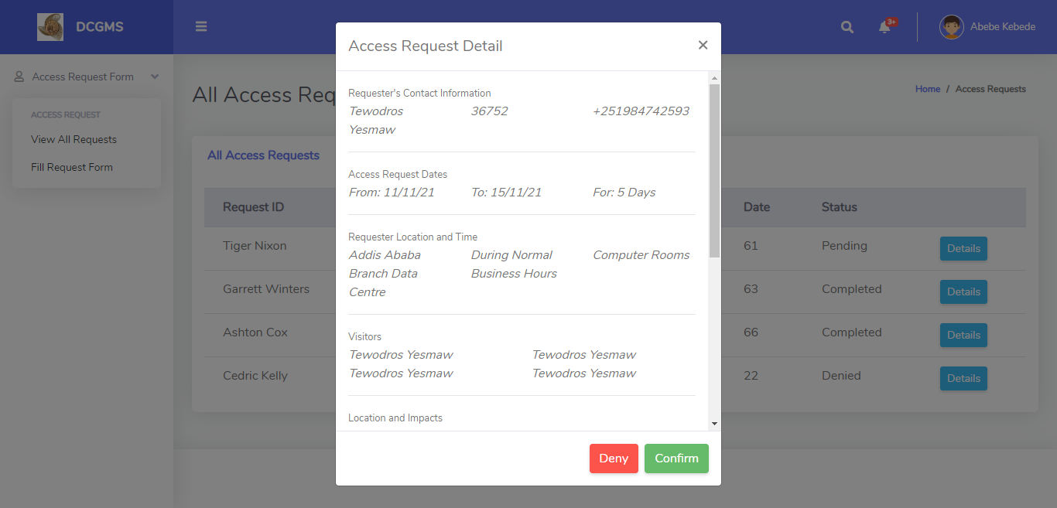

Figure 12: DC Manager Request Deny

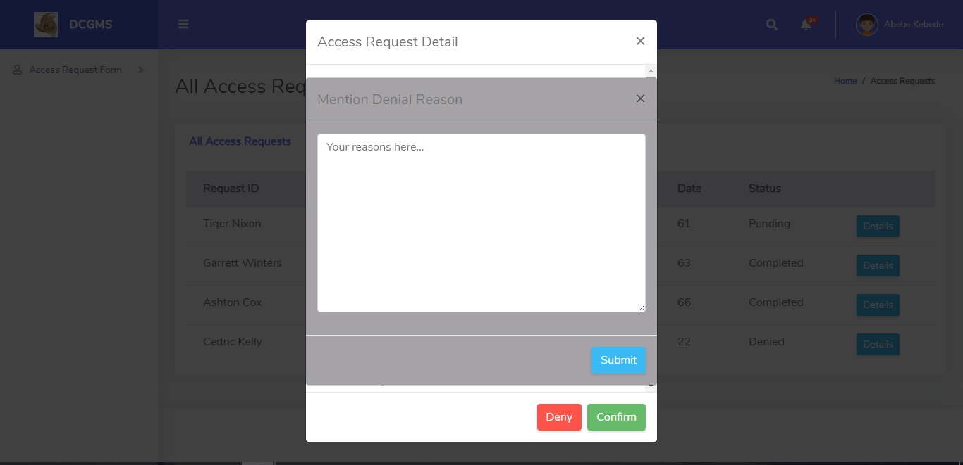

### 

### Hardware Interfaces

DCGMS has no dependencies with any hardware interfaces.

### Software Interfaces

To run DCGMS, A user must be connected with CBE’s local network. There is no OS requirement to be specified as long as it has an Internet Browser.

### Communication Interfaces

DCGMS will use HTTP protocol for communication.

## Functional Requirements

|  |  |
| --- | --- |
| Name | FR. 01: Logging to the system (super admin) |
| Input | Email and password |
| Description | The super admin provides his/ her email and password to log into the system |
| Output | Login successfully. |
| Error Handling | Put constraints to the input fields of the login form. |

|  |  |
| --- | --- |
| Name | FR. 02: System users registration (super admin) |
| Input | Full name, phone number, unit, valid email address and password |
| Description | The super admin provides the required information and the system will create an account. |
| Output | Account is successfully created. |
| Error Handling | Put constraints to the input fields of the registration form. |

|  |  |
| --- | --- |
| Name | FR. 03: Reset Password (super admin) |
| Input | New password |
| Description | The super user inputs new password and confirms it. |
| Output | Password is successfully reset. |
| Error Handling | Put constraints to the input fields of the password form. |

|  |  |
| --- | --- |
| Name | FR. 04: Remove Account (super admin) |
| Input | user |
| Description | The system will let the super admin to remove the user. |
| Output | User is removed. |
| Error Handling | --- |

|  |  |
| --- | --- |
| Name | FR. 05: Login (IS unit manager(requester)) |
| Input | Email and password |
| Description | Provide valid email and password |
| Output | Successfully logged in. |
| Error Handling | Put constraints to the input fields of the login form. |

|  |  |
| --- | --- |
| Name | FR. 06: Fill Access Request Form(IS unit manager(requester)) |
| Input | Full name, phone number, ID number, starting date and end date, access required location, access time, areas to be accessed, 1st personnel, 2nd personnel, 3rd personnel, 4th personnel, location, impact and visit purpose |
| Description | The user provides all necessary information and submit |
| Output | Request submitted successfully. |
| Error Handling | Put constraints to the input fields of the login form. |

|  |  |
| --- | --- |
| Name | FR. 07: View Access Requests (IS unit manager(requester)) |
| Input | --- |
| Description | The system provides the user with all access requests so far |
| Output | Successfully presented list of requests. |
| Error Handling | --- |

|  |  |
| --- | --- |
| Name | FR. 08: View Details of Access Request (IS unit manager(requester)) |
| Input | --- |
| Description | The system provides the user with all details about the selected access request. |
| Output | Successfully presented details of the request. |
| Error Handling | --- |

|  |  |
| --- | --- |
| Name | FR. 09: View notifications (IS unit manager(requester)) |
| Input | --- |
| Description | The system notifies the user about the status of a submitted request. |
| Output | Successfully presented the notification. |
| Error Handling | --- |

|  |  |
| --- | --- |
| Name | FR. 10: Login (DC manager(confirmer)) |
| Input | Valid email and password |
| Description | Provide valid email and password |
| Output | Successfully logged in. |
| Error Handling | Put constraints to the input fields of the login form. |

|  |  |
| --- | --- |
| Name | FR. 11: View Access Requests (DC manager(confirmer)) |
| Input | --- |
| Description | The system provides the user with a list of access requests in descending order. |
| Output | Successfully presented the list. |
| Error Handling | --- |

|  |  |
| --- | --- |
| Name | FR. 12: View Details of Access Request (DC manager(confirmer)) |
| Input | --- |
| Description | The system provides the user with details of the selected access request. |
| Output | Successfully presented the details. |
| Error Handling | --- |

|  |  |
| --- | --- |
| Name | FR. 13: Confirm a request (DC manager(confirmer)) |
| Input | --- |
| Description | The system allows the user to confirm the request. |
| Output | Successfully confirmed. |
| Error Handling | --- |

|  |  |
| --- | --- |
| Name | FR. 14: Denying request (DC manager(confirmer)) |
| Input | Denial reason |
| Description | The system allows the user to input the denial reason in the provided field |
| Output | Successfully committed denial. |
| Error Handling | --- |

|  |  |
| --- | --- |
| Name | FR. 15: Login (Inf. manager(approver)) |
| Input | Valid email and password |
| Description | Provide valid email and password |
| Output | Successfully logged in. |
| Error Handling | Put constraints to the input fields of the login form. |

|  |  |
| --- | --- |
| Name | FR. 16: Views confirmed requests (Inf. manager(approver)) |
| Input | --- |
| Description | The system provides the user with a list of confirmed requests. |
| Output | Successfully presented the data. |
| Error Handling | --- |

|  |  |
| --- | --- |
| Name | FR. 17: Views details of a confirmed request (Inf. manager(approver)) |
| Input | --- |
| Description | The system provides the user with details of a confirmed request. |
| Output | Successfully presented the data. |
| Error Handling | --- |

|  |  |
| --- | --- |
| Name | FR. 18: Approves a confirmed request (Inf. manager(approver)) |
| Input | --- |
| Description | The system lets the user to approve the request. |
| Output | Successfully approved. |
| Error Handling | --- |

|  |  |
| --- | --- |
| Name | FR. 19: Reject a confirmed request (Inf. manager(approver)) |
| Input | Rejection reason |
| Description | The system allows the user to input the rejection reason in the provided field |
| Output | Successfully reject the request. |
| Error Handling | --- |

|  |  |
| --- | --- |
| Name | FR. 20: Fill Access Request Form for Permanent visitors(Inf. manager(approver)) |
| Input | Full name, phone number, ID number, starting date and end date, access required location, access time, areas to be accessed, 1st personnel, 2nd personnel, 3rd personnel, 4th personnel, location, impact, scanned letter and visit purpose |
| Description | The user provides all necessary information and submit |
| Output | Request submitted successfully. |
| Error Handling | Put constraints to the input fields of the login form. |

|  |  |
| --- | --- |
| Name | FR. 21: View Approved requests (DC Admin) |
| Input | --- |
| Description | The system provides the user with a list of approved requests in descending order. |
| Output | Successfully presented the list. |
| Error Handling | --- |

|  |  |
| --- | --- |
| Name | FR. 22: View details of a request (DC Admin) |
| Input | --- |
| Description | The system provides the user with details of the selected approved request. |
| Output | Successfully presented details. |
| Error Handling | --- |

|  |  |
| --- | --- |
| Name | FR. 23: Search for a request (DC Admin) |
| Input | Request ID |
| Description | Provide the request ID generated by the system to search for the specific request |
| Output | Successfully presented details of a list. |
| Error Handling | Put constraints to the input field of the search form. |

|  |  |
| --- | --- |
| Name | FR. 24: Writes a review on the visit (DC Admin) |
| Input | Review text |
| Description | Provide a short review about the currently active visit. |
| Output | Successfully submitted the review. |
| Error Handling | Put constraints to the input field. |

|  |  |
| --- | --- |
| Name | FR. 25: Manage a request from top management (DC Admin) |
| Input | Full name, phone number, ID number, starting date and end date, access required location, access time, areas to be accessed, 1st personnel, 2nd personnel, 3rd personnel, 4th personnel, location, impact, visit purpose and **scanned letter** |
| Description | The user provides all necessary information and submit |
| Output | Successfully submitted the request. |
| Error Handling | Put constraints to the input fields of the login form. |

## Use Case Diagrams

### Use Case – 01: Super Admin Login

* Use Case Name: Super Admin Login
* Primary Users: Super Admin
* Summary: The system will authenticate the user and redirect to the dashboard
* Pre-condition: The user must register in the system manually
* Post-condition: The system will let the user access his account and do the specified activities mentioned in the functional requirements
* Trigger: The user navigates to his login page
* Main Success Scenario:
  1. The super admin navigates to the system’s portal and click login button
  2. The system redirects the user to the login page
  3. The user fills the required fields
  4. The system validates the user credentials
  5. The system redirects the user to home page
* Extensions:
  1. If the credentials are incorrect, the system will tell the user to enter correct email and password

### Use Case – 02: System Users Registration

* Use Case Name: System Users Registration
* Primary Users: Super Admin
* Summary: The system will let the super admin to register different users of the system
* Pre-condition: The super admin must login
* Post-condition: The super admin successfully register other users of the system
* Trigger: The super admin navigates to add users page
* Main Success Scenario:
  1. The super admin clicks the add new users button
  2. The system redirects the super admin to add new user page
  3. The user fills the required fields
  4. The system will create new user account
  5. The system gives a ‘user registered successfully’ flash message
* Extensions:
  1. If the super admin enters invalid fields, the system will ask him/ her to enter valid information

### Use Case – 03: Reset Password

* Use Case Name: Reset Password
* Primary Users: Super Admin
* Summary: The system will let the super admin to reset a password for other users
* Pre-condition: The super admin must login
* Post-condition: The system will provide a reset button and password input fields
* Trigger: The super admin clicks a password reset button
* Main Success Scenario:
  1. The super admin clicks a password reset button
  2. The system redirects the super admin to a password reset page
  3. The super admin selects the user who lost his/ her password
  4. The super admin enters new password and confirm it and submit
  5. The system flashes a successful message
* Extensions:
  1. If the inputs are invalid, the system will let know the super admin

### Use Case – 04: Remove Account

* Use Case Name: Remove Account
* Primary Users: Super Admin
* Summary: The system will delete the existing account
* Pre-condition: The super admin must login and navigate to a remove account page
* Post-condition: The system will let the super admin to delete the selected users account from the system’s users database
* Trigger: The user navigates to remove accounts page
* Main Success Scenario:
  1. The super admin navigates to the remove account page
  2. The super admin selects the user to whom the user account is going to be removed
  3. The super admin confirms the remove account popup
  4. The system removes the user from the database
  5. The system redirects the user to home page
* Extensions:

### Use Case – 05: Login (All other users)

* Use Case Name: Login
* Primary Users: All other users(IS Unit Managers, Data Centre Manager, Infrastructure Manager and Data Centre Admins and/ or Receptionists
* Summary: The system will authenticate the user and redirect to the respective dashboard
* Pre-condition: The user must be registered and own a valid account
* Post-condition: The system will let the user access his account and do the specified activities mentioned in the functional requirements
* Trigger: The user navigates to his login page
* Main Success Scenario:
  1. The user navigates to the system’s portal and click login button
  2. The system redirects the user to the login page
  3. The user fills the required fields
  4. The system validates the user credentials
  5. The system redirects the user to home page
* Extensions:
  1. If the credentials are incorrect, the system will tell the user to enter correct email and password

### Use Case – 06: Fill Access Request Form

* Use Case Name: Fill Access Request Form
* Primary Users: IS Unit Manager
* Summary: The system will provide a request form and accept information about the request
* Pre-condition: The user must login to the system
* Post-condition: The system will let the user fills the form and submit it
* Trigger: The user navigates to request form page
* Main Success Scenario:
  1. The user navigates to a request form page
  2. The user fills all the required fields
  3. The user submits the form
  4. The system flashes a successful message
  5. The system redirects the user to home page
* Extensions:
  1. If the information are invalid, the system will tell the user to enter correct information

**Use Case – 07: View Access Requests**

* Use Case Name: View Access Requests
* Primary Users: IS Unit Manager
* Summary: The system will present all access requests in descending order
* Pre-condition: The user must login to the system
* Post-condition: The system will let the user navigate through all submitted access requests
* Trigger: The user clicks access requests button
* Main Success Scenario:
  1. The user clicks on access request button
  2. The system presents all access requests in descending order
* Extensions:

# Logical Database Requirements

When and only when the database of the system exists that the whole system functions as a whole. So, the backend of the system is one of the biggest requirements that is going to be addressed. Our database will be stored in the file format of MySQL, this file format is reliable and robust but most of all in this file format we have a lot of built in futures like transactions, cascading delete/update, index and speed. The database is only accessible for those that have relevant administrative privileges. The database is monitored and modified from the selected pages by inserting the needed information’s.

Here is list all the database data, attributes and also the description of the databases.

|  |  |  |
| --- | --- | --- |
| Data | Attributes | Description |
| Admin Data | * email * password | Stores data about login information of the super admin |
| User Data | * full_name * phone_number * unit * email * password | Stores data about user account information |
| Request Data | * full name * phone number * id_number * date * starting_date * end_date * remaining_days * access_request_location * access_time * areas_tobe_accessed * personnel1 * personnel2 * personnel3 * personnel4 * location * impact * purpose * scanned_letter_data * request_id | Stores data about the request |
| Reset Password Data | * email * password | Stores data about password reset |
| Request Denial Data | * request_id * denial_reason | Stores data about denial reason |
| Request Rejection Data | * request_id * rejection_reason | Stores data about rejection reason |
| Search Request Data | * search_input |  |
| Request Review Data | * request_id * review_text | Stores data about request review |